Course Title
Session Name and Date
OBJECTIVES: Upon completion of this session, students will be able to: | LENGTH
Web-Based Delivery:  - Objective 1  - Objective 2  - Objective 3  - Objective 4 | 90 minutes

Topics | Min
Welcome | 3
Objectives & Agenda | 2
Lecture Topic | 15
Poll | 5
Lecture Topic | 15
Discussion/Activity | 10
Lecture Topic | 15
Poll | 5
Lecture Topic | 15
Objectives Review & Wrap-up | 2
Q&A | 3
Total | 90

Session Title | Session Title
Introductory Statement | Welcome to Session Title. This may be the first time you are experiencing a live class delivered via the web, so we will spend a few minutes introducing you to the Zoom features. However, first, I’d like to introduce myself. [Introduce yourself]  Now, let’s look at Zoom. On your screens, you see the Zoom virtual meeting room. At this time, I have muted your microphones so that there isn’t any background noises from the participants.  Mute/Unmute & Audio Settings  You can mute and unmute your microphone. If you click on the arrow next to the mute button, you will have additional options for audio settings. You can change your microphone, leave the computer audio or access the audio options.  Start/Stop Video & Video Settings  You can turn your camera on or off with the Start/Stop Video button. By clicking on the arrow next to the start/stop video button, you can change webcams, access your Zoom video settings, or select a virtual background (if enabled).  Participants  If you click on Participants, you can see who is currently in the meeting. The participant’s list also gives you the option to raise your hand or rename yourself.  - Raise Hand - notifies host and shows a prompt to simulate hand raise  - Rename - hover over your name to change it as it is seen in the participant’s list and video window  Chat  Chat with individuals or everyone in the meeting. Click Chat to open up the chat window and chat with other participants or view chat messages. Select the drop-down next to To: to change who you are chatting with.
.

Visual On Screen | Script to Be Read/Talking Points to be Covered
 | Display the slide and read the introductory statement (see above).
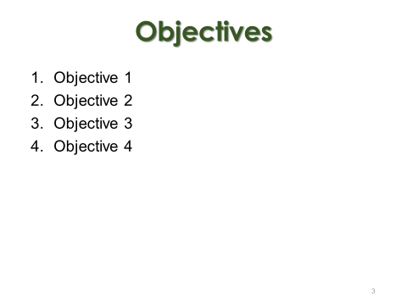  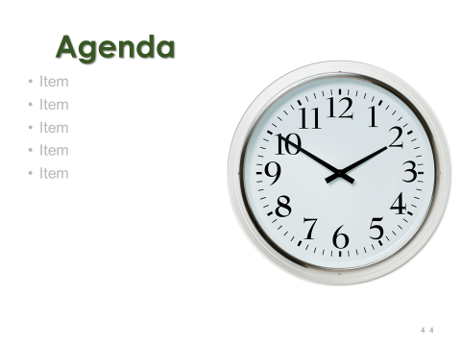 | Welcome participants to the class session. This is an excellent time to conduct an icebreaker.  Review the objectives.  Review the agenda.
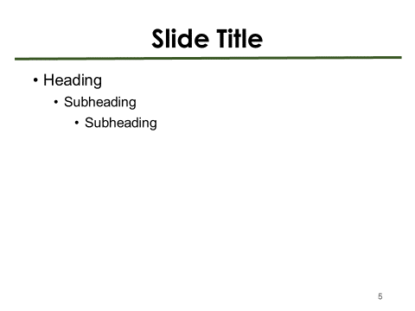 | Explain the bullets on the slide. Avoid reading directly from the slide. Instead, summarize the points in your own words. Avoid lecturing for more than 15 minutes as this is a best practice when teaching adult learners.  .
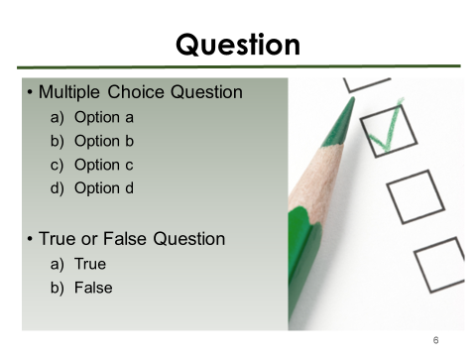  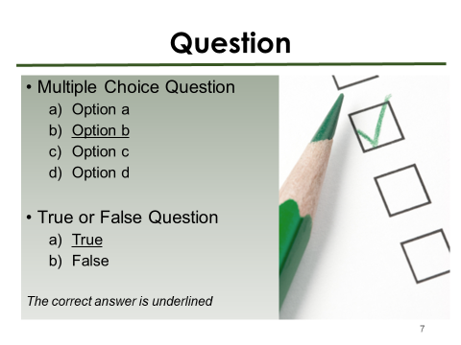  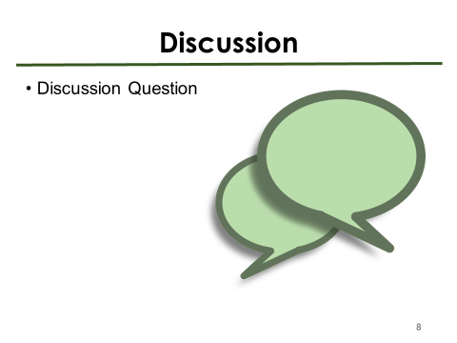  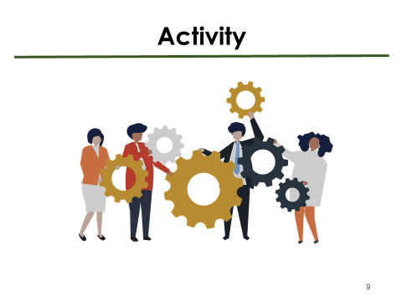 | Read the question and instruct participants to use the chat feature to respond.  Reveal the answer.  Read the discussion question and instruct participants to use the chat feature or unmute to respond.  Explain the group activity to participants.
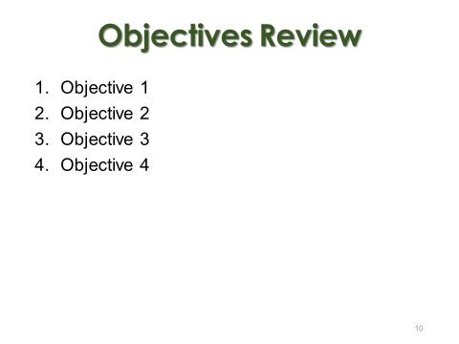  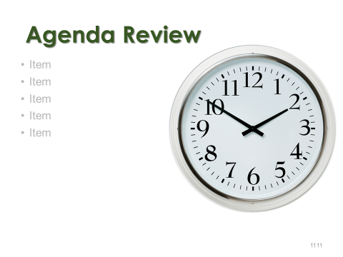 | Review the objectives.  Review what was covered in class.  Ask participants if they have any questions. Instruct participants to use the chat feature.
 | Thank the participants for joining the session.

